Te Roopu Reo Rua Wha (TRRR4)
Whaea Cammy
16.08.20

Keep a daily journal of the activities you did and how you’re feeling. | Read a book with your whānau. | Create a dance or song alongside your whānau.
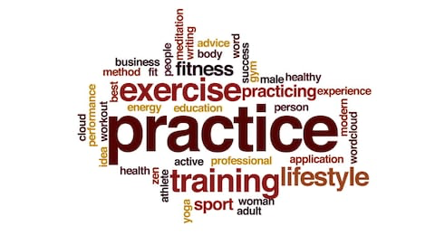  Practice what we have already learnt in class. (TR4 chant & dance, mihimihi, speech, mau rākau) | 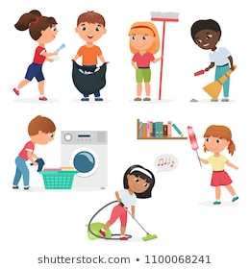  Help tidy up. | Count everything. (The number of cars that drive pass your whare, the number of houses on your street)
Bake/Cook something alongside the whānau. | Learn a new game alongside your whānau. | 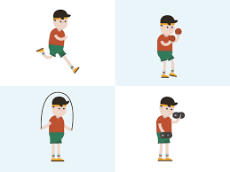  Learn and teach your whānau your own personal workout routine.

Online learning
Websites
Literacy | Numeracy | Other Learning Areas
- ePic - Online Reading (Audio and Activities)  Student code - zua0913  https://www.getepic.com/students  - Scholastics - Online Writing Prompts  http://www.scholastic.com/teachers/story-starters/ | - Prodigy - Online Maths  Student login information - Prodigy login  https://play.prodigygame.com/  - Prototec - Online Maths  https://maths.prototec.co.nz/  - NZ Maths - Follow the links  https://nzmaths.co.nz/units-work  - Word problems https://www.dadsworksheets.com/worksheets/word-problems.html | - Storyline Online https://www.storylineonline.net/  - Fun Brain https://www.funbrain.com/
Te Reo Māori
He aha teenei?: River Rush: 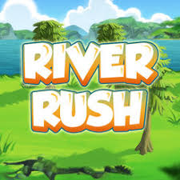 Tipu: 