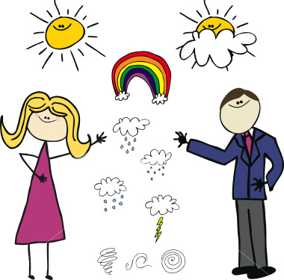  Enjoy the day outside thinking about these questions.  What is today?  What was yesterday?  What will be tomorrow? | Help your Mum to make your breakfast  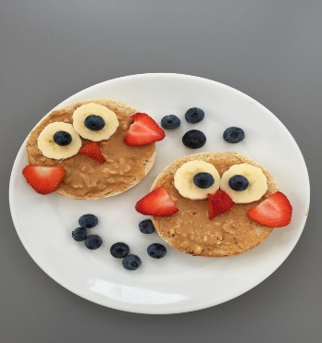  Have fun by decoration your breakfast with fruits or nuts.  Draw and write about it | 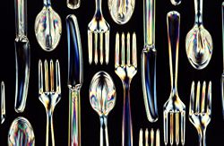  Lau e huhu, sepuni, hele, ipu mo e peleti kai ‘i homou peito.  Lau 2, 5  mo e 10  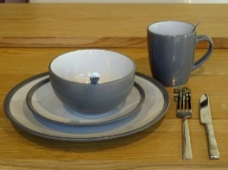  Count how many plates, cups. forks and knives in the kitchen  Count in 2s, 5s, and 10s
How to keep you healthy at home?  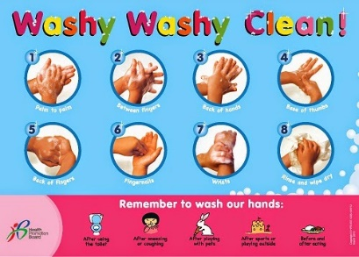  Write the steps to follow  1.  2. | Ta e fasi faka-Tonga pea ke tauólunga faka-Tonga mo ho tokoua pe fa’ee.  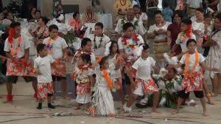  .  Play a Tongan song and do a dance with your brother or sister or Mum | Play tag with your siblings outside. Pick up leaves of different kinds.  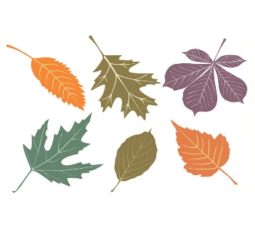  Make your own design of leaves.
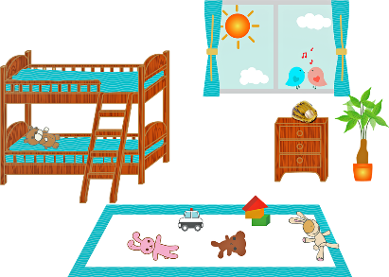  Ta ho fale ko ho papolo ia. Tohi pe ha me’a ‘e 10 ‘oku ke sio ai ho fale  Draw your bubble (house).  Write down 10 things you’ve seen in your bubble | Sio he hiva ABC he youtube.  Sing along ABC on YOUTUBE | FUN TIME  Cutting and Pasting  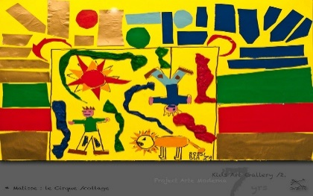  Cut any pictures you like from newspapers and glue it to a white paper as a collage.

