SM3 Home Learning Week 2
Write a letter to the main character of the last book you read.  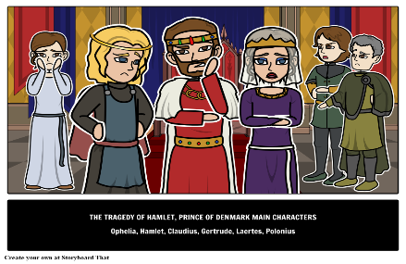 | Tohi ha lisi ‘o e ngaahi talanoa faka - Tonga ‘e 15 na’a´ke ‘osi lau.  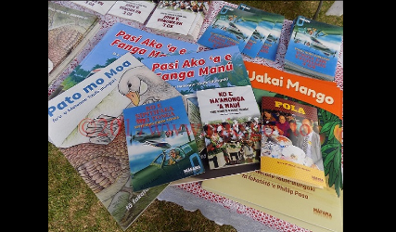 | Write a silly story about a talking animal in English and Tongan.  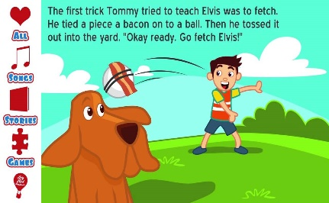
Write a BIG list of words starting with the first letter of your first name. Example:  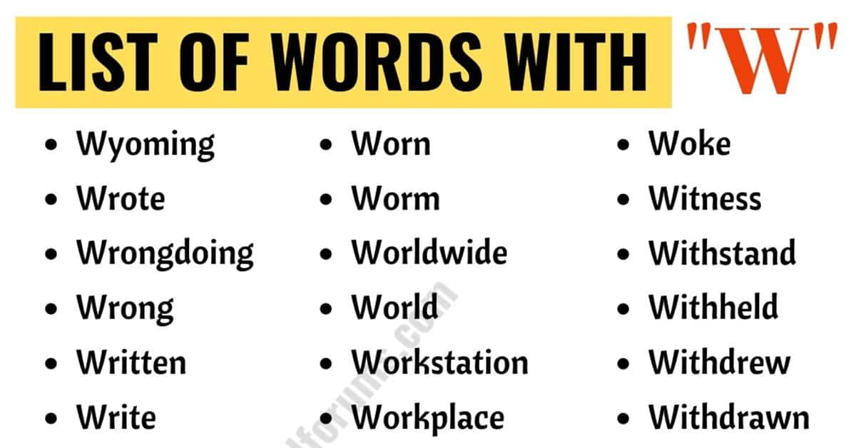 |  | Draw and label your favourite meal.
Write and draw 5 things that describe you | 1. I think of a number. I half it, then takeaway 4 and my answer is 6. What was my number?  2. I think of a number. I add 7 and then double it. My answer is 20. What was my number?  3. I think of a number. I half it, then add 5 and my answer is 9. What was my number? | Basic facts ladder  The number is 10  Half  Triple  Plus 5  Double  Divide by 2  Quarter it  Take away 4  Times 10  Square it  The answer is ______.  Add your own number
Draw a poster on ‘How to manage yourself in the classroom’ | Tā ha fasi faka-Tonga pea´ke fakamālohisino ‘o fakatonu ki he fasi´. | Help relax your mind with some mindful colouring.

